
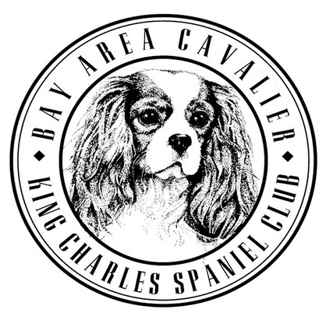
Bay Area Cavalier King Charles Spaniel Club
General Membership Meeting Notice
Please join us for a potluck lunch, followed by our general membership meeting and our Annual Awards Presentation!

January 25, 2026
Potluck at 11:30 am
Meeting & Awards Presentation at 1:00 pm

Home of Heather Rezowalli
2 Sunglen Way, Danville, CA 94506

Annual Awards
Please help us celebrate the accomplishments of our members and their Cavaliers in 2025! If your dog earned a new title in 2025 (eligibility period: January 1, 2025 - December 31, 2025), please send the following information to Allyson Gonyo at allysongonyo@outlook.com by January 20th:
registered name including all titles call name
title(s) earned in 2025 photo of your dog name of owner(s)

Potluck Lunch
Please contact Julie Ellingson at gyldencavaliers@gmail.com to sign up for the potluck lunch. Please RSVP by January 20th.

Please note, no dogs at this meeting.

